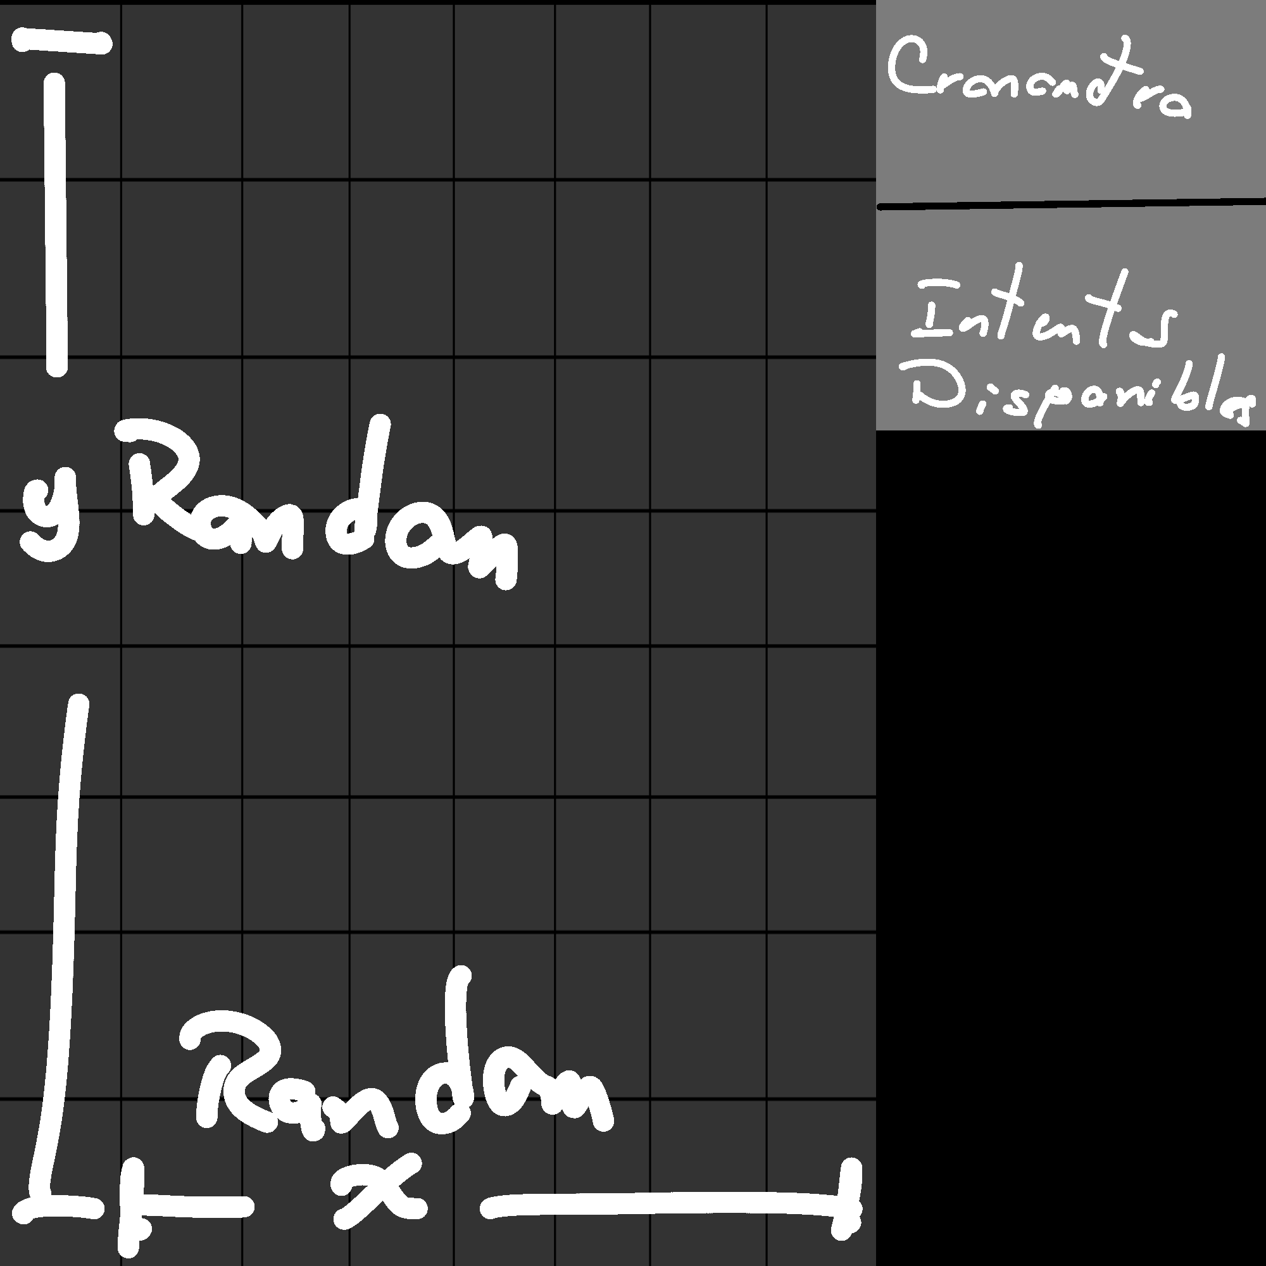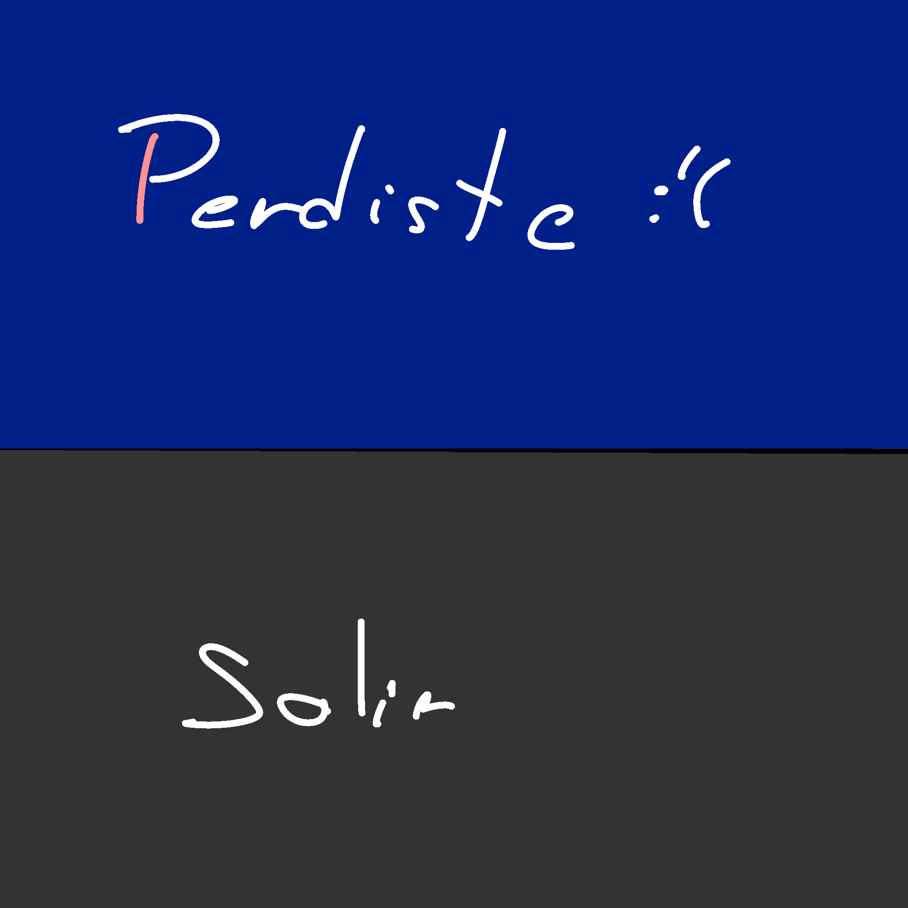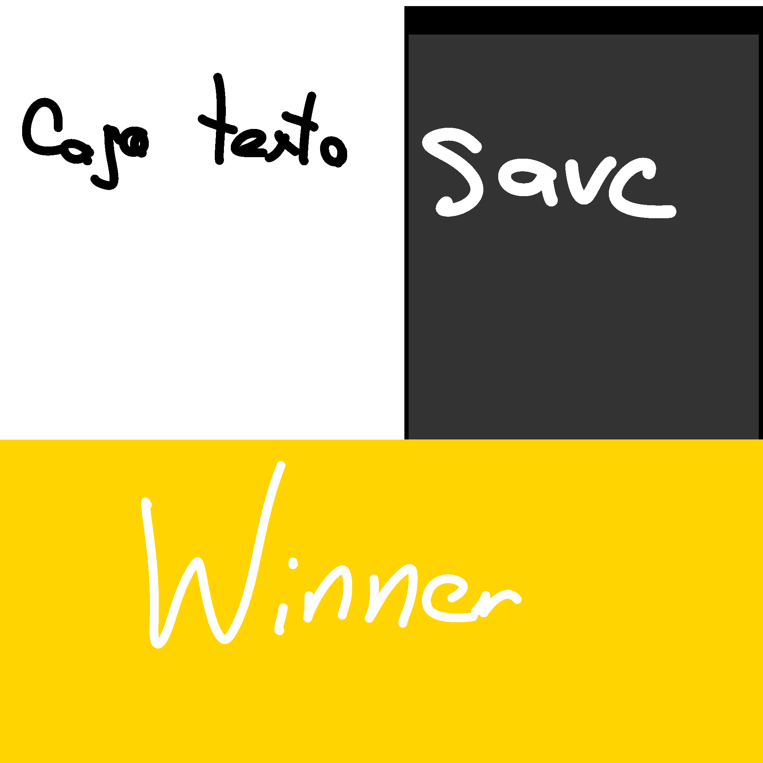

|  |  |  |  |
| --- | --- | --- | --- |
| Rank | Nombre | Tiempo | intentos |
|  |  |  |  |
|  |  |  |  |
|  |  |  |  |
|  |  |  |  |
|  |  |  |  |
|  |  |  |  |
|  |  |  |  |
|  |  |  |  |
|  |  |  |  |
|  |  |  |  |